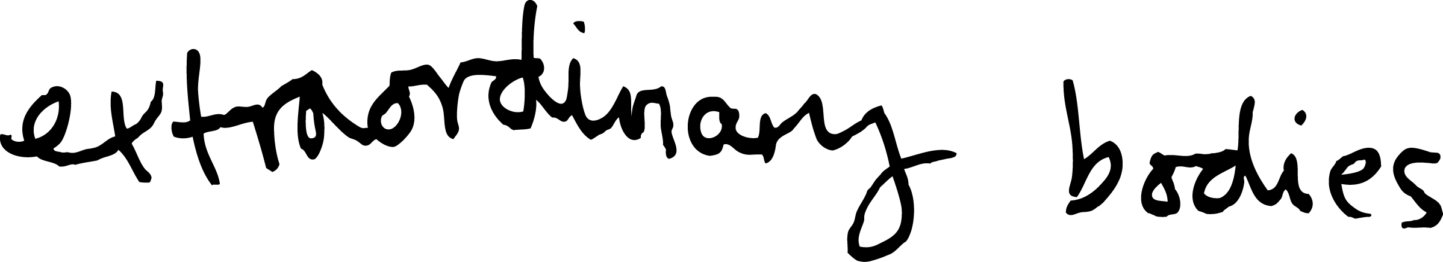

**Job Title: Assistant Producer (participation) – Extraordinary Bodies.**

Responsible to: Executive Producer

Responsible for: Successful practical delivery of 10 ‘Creative Exploration’ sessions.

**Extraordinary Bodies**

Extraordinary Bodies is the UK’s leading integrated circus company. We create joyful, radical and bold performance and increase awareness, capacity and leadership for integrated arts practice nationally. A collaborative partnership between Cirque Bijou and Diverse City, together we are experts in outdoor arts, spectacle, circus, theatre, integrated performance and community engagement.

Extraordinary Bodies toured the UK in 2015/16 with their show ‘Weighting’ to over 8,000 people and they are working with Circus Oz, as well as the National Theatre London and others to create their next show 'What am I Worth?’ which will première in 2018. The Creative Explorations are the second community focused development phase for the show.

**Job purpose:**

* To manage a UK and Ireland wide series of Community Creative Explorations. These are circus, theatre and music sessions run by the company, working with different groups from 10 locations. These groups will vary and all will have a mix of people such as community members, marginalised groups Deaf, disabled and learning disabled people.

**Project Background:**

Extraordinary Bodies is working with partners in Cardiff, Dorset, Glasgow, London, Plymouth, Ireland, Telford, Nottingham, Bristol, Weston-Super-Mare to deliver 10 ‘Creative Explorations’ with people in each location. These sessions are a key part of the development of Extraordinary Bodies show ‘What Am I Worth?’

**Main areas of responsibility:**

* To ensure that the Creative Explorations happen on time and within budget.
* To be responsible for overseeing successful project delivery including objectives regarding attendance, evaluation, timing
* To manage practical set up of each session in liaison with the Extraordinary Bodies Executive Producer and each local partner/venue
* To update on progress and manage any potential issues before they become problems
* First point of contact between Extraordinary Bodies and community groups.
* Scheduling all artists and staff and working to deadline.

**Tasks:**

* Schedule company diaries, create production schedules,
* Availability check artists, contract and agree employment terms
* Organise delivery of session equipment/materials
* Book accommodation & group travel
* Collect health and safety paperwork/risk assessments
* Manage individual session budgets - travel and per diems etc - in liaison with Executive Producer
* Book access provision for artists (training available)
* Attend the start/end of some of the sessions to assist company
* Collect and Collate feedback at each session
* Capture and collate digital footage/images for social media and evaluation reports
* Outreach/Promotion work to help partners locally to attract people to the sessions (where necessary) and to communicate session timings/logistics/parking etc

**Start date**

Immediate start in February/early March 2017 until early 2018. Sessions are mostly 4/5 days long in each location and the bulk of the work will need to be done between February and November 2017.

**Terms**

This is a freelance position with a fee of £7,300 inclusive of Assistant Producer’s travel and accommodation*

*Travel and accommodation is not expected for all sessions.

**Location**

Cirque Bijou and Diverse City are committed to flexible and inclusive working practices. The Assistant Producer (participation) will be expected to attend regular face to face meetings in Bristol: there is space to support co working and systems to support remote working. Extraordinary Bodies Executive Producer works out of Cirque Bijou’s Bristol office. This role involves some travel outside Bristol but doesn’t involve being at all sessions for all of the time (1 or 2 days ideally).

**Access**

Deaf and Disabled applicants will be interviewed. If you have any specific access requirements please specify what they are and whether you are registered for an Access to Work grant when you apply. In the event that our proposed structure presents access barriers, you are invited to propose other ways that this role might be undertaken.

**To apply please send your CV along with a 3 minute recording to camera (e.g a smartphone camera) telling us why you think you are suitable for the role.**

**Application deadline:** Midday on 7th February 2017

**Interviews:** 22nd February 2017 in Bristol

Please email applications to the email below or to discuss this role, or if you have any questions, please contact Claire Teasdale: 0117 9029730 / claireteasdale@extraordinarybodies.org.uk

**Please email applications to info@diversecity.org.uk**