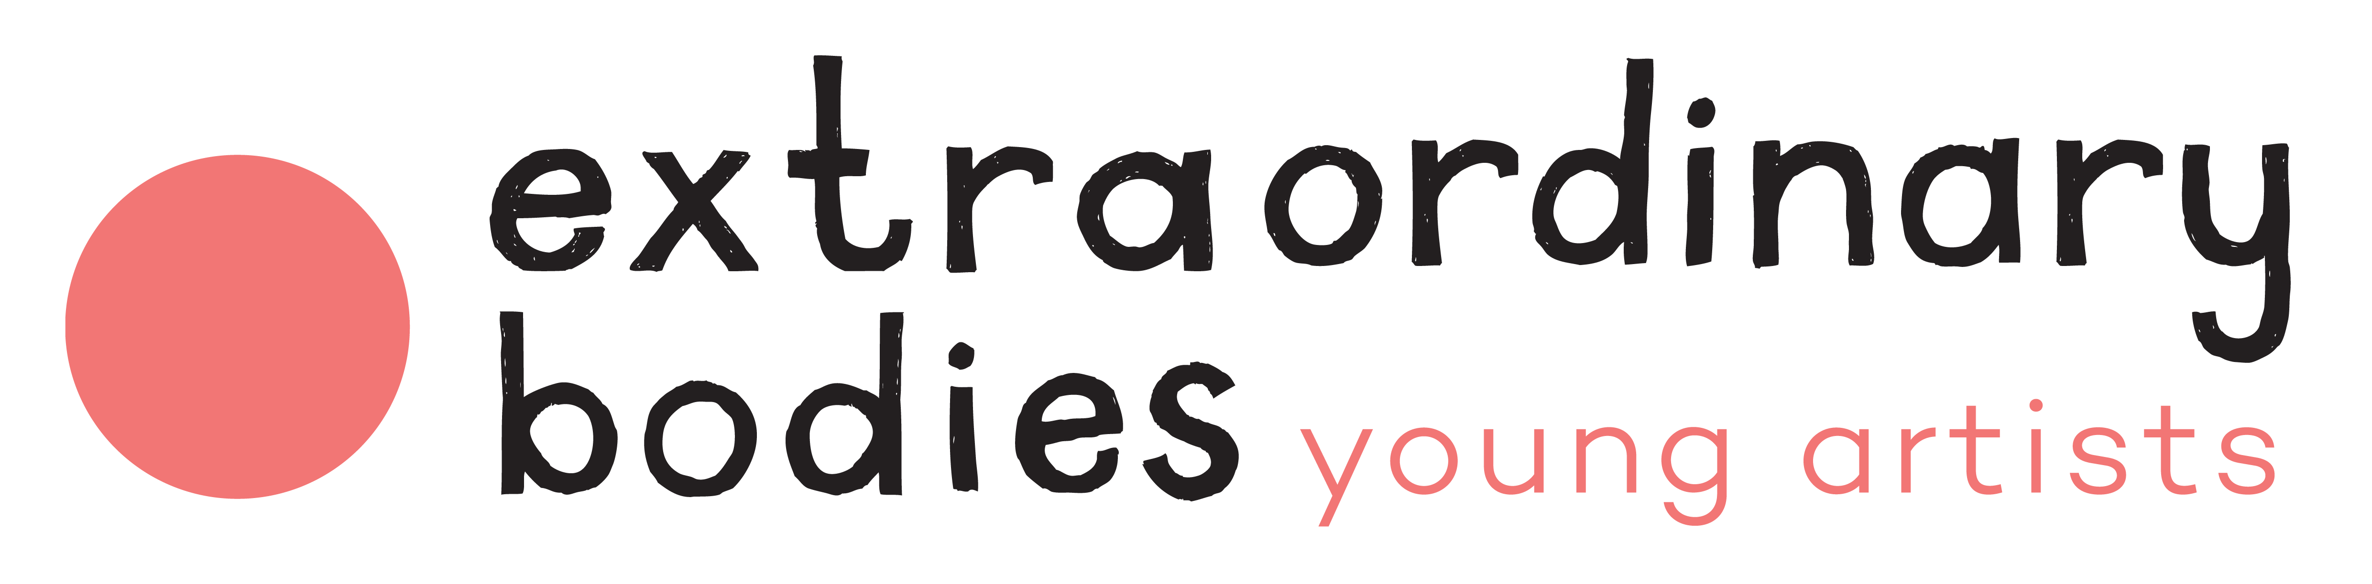

**Technical Manager (Freelance) Job Description**

[Extraordinary Bodies](http://extraordinarybodies.org.uk) is looking for a freelance technician to collaborate on Extraordinary Bodies Young Artists live and digital performance programme on a part-time basis for 10 months in 2021.

**The basics**

**Reports to:** Children’s & Young People Team.

**Location:** Flexible but close to Poole, Dorset (EBYA meet in Poole weekly).

**Freelance Fee**: £200 day rate. Total contract approximately 28.5 days, part time spread across 10 months.

**Contract term:** February – November 2021.

**The timeline**

**Applications Deadline**: 5pm 18th February 2021  
**Interviews**: 25th February 2021  
**Start Date**: Flexible , beginning of March 2021

**About Extraordinary Bodies Young Artists**

Extraordinary Bodies Young Artists is an inclusive theatre company for 16-30s in the Poole, Bournemouth and Dorset area. The company are closely linked to Extraordinary Bodies – a leading professional integrated circus company. Extraordinary Bodies Young Artists offers performance skills, training and mentoring from incredible professional artists with expertise in:

* Theatre
* Music
* Dance
* Aerial Circus Performance

Together we devise ambitious, challenging work which we perform across the UK. EBYA exists to support young artists at the start of their careers and bursary places are available.

**Your responsibilities**

You are a technical whizz supporting our inclusive youth performance company as we navigate new digital ways of working over the next year. Through lockdowns in 2020 we have successfully run inclusive Zoom workshops, rehearsals and digital sharing’s. You will be responsible for taking this to the next level and your skills, drive and passion will open up new digital possibilities for our creative performance-making. You will support all of the company’s technical requirements at weekly rehearsals, workshops and performances. You will help remove barriers to participation and open up the possibilities of remote connection – for example some of our artists may be shielding, isolating or not be able to travel to live sessions. You ensure those accessing events remotely to have a high-quality experience which equals that of those in the room.

**Your To Do list**

* Manage the technical requirements for regular online workshops and rehearsals remotely via Zoom.
* Support the company to develop hybrid methods of working which combines artists together in a rehearsal space with digital remote link ups.
* Lead on introducing new equipment (cameras, microphones, lighting etc) and/or software and setting up new digital experiments to enhance the creative process.
* Provide clear instructions on how to upload film, audio and written work from home and set up clear and safeguarded digital systems for our participants.
* Support live and digital shows as a technician.
* Put access and inclusion at the heart of this work so that those facing barriers are at the centre of our creative digital practise in 2021 and beyond.
* Contribute to risk assessments and lead on lighting and sound plans for the company.
* Set and maintain excellent levels of safeguarding and health and safety with all the companies digital and live work.

**Supporting the Children and Young People’s targets at Diverse City:**

* Devise and contribute to EBYA risk assessments.
* To understand the importance of handling sensitive data on a need to know basis and to be GDPR compliant.
* To actively contribute to regular CYP team meetings reviewing activity and planning.
* To actively contribute to evaluation and documentation as required.

**Planned Programming for 2021:**

**Weekly sessions**  
Thursday evenings during term time 6:30-8pm online via Zoom and/or at Lighthouse, Poole.

**Weekend and school holiday workshops:**   
Easter holidays (w/c 5th April) x 4 days: Poole or Online  
Weekend workshops in May and July (TBC): Poole

**Performances (dates TBC):**  
July: European Youth Theatre Festival, Birmingham (Residential)  
October: Funky Llama Festival, Plymouth  
November: Lighthouse, Poole

**We’d love to meet people who have the following**

* Experience of working or volunteering in a theatre or creative environment as a technician.
* Excellent digital skills and confidence in using Q-Lab, Zoom, Dropbox, Vimeo, YouTube, projectors, soundboards, lighting rigs etc. Experience of live-streaming would be beneficial.
* Good research skills to support the company in finding the right technology and equipment to enhance the work. A problem-solving attitude.
* Interest in the performing arts and willingness to get involved in creative activity.
* A friendly and positive attitude, quick to support tasks in a proactive way; encouraging enthusiasm and inclusion in others.
* Understanding and ability to apply the social model of disability to the role.
* Ability to adapt and grade communication to a wide range of people.
* High standards of confidentiality, discretion, initiative and tact.
* Ability to remain calm in stressful situations.

**And maybe a bit of this too:**

* Experience and knowledge of live-streaming.
* Driving /clean driving license/business insurance or ability to get to rehearsal locations independently.
* DBS check (we will arrange this if you don’t hold a current DBS check).

**How to apply**

If you think you are a good fit for the role, please send your application to [info@diversecity.org.uk](mailto:info@diversecity.org.uk) by **5pm on Thursday 18th February.**

**Your application should include:**

1. Your CV (maximum 1-page A4) plus Names and contacts for 2 referees
2. A short, filmed statement, to camera, about yourself and how you fit this job role (max 3-4 minutes long).

Please complete:

* [Equal Opportunities Monitoring Form](https://forms.gle/4TYm8U6RJ9ewsg2d8) (this will not be attached to your application).
* [Access Audit](https://forms.gle/6bkbsZWExgX3tzE27) so we can arrange access requirements.

**Equality and Diversity**

Diverse City values equality and strives to promote diversity at all levels. We welcome and actively seek applications from those currently underrepresented in our workforce and the arts community, particularly people of colour, and disabled people (as defined by the Equality Act 2010).

We will guarantee an interview to any D/deaf or disabled candidate or person of colour who fulfils the criteria for the role and we are open to proposals of ways this role might be undertaken if our proposed structure presents barriers to any applicant.

**Access**

If you have any specific access requirements please tell us what they are in the [Access Audit](https://forms.gle/6bkbsZWExgX3tzE27) and whether you are registered for an Access to Work grant when you apply.

If you would like the Job Description in another format or if you need further information, please contact [info@diversecity.org.uk](mailto:info@diversecity.org.uk).

**About us**

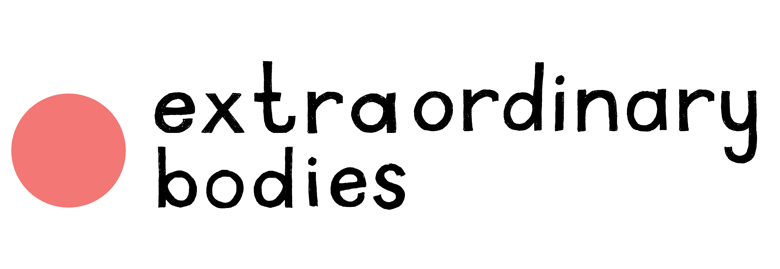

**Extraordinary Bodies** is the established partnership between Diverse City and Cirque Bijou, seeded in 2012 and formally created in 2013.



[**Diverse City**](http://diversecity.org.uk) is a charity where culture and social action meet. It is an award-winning, Dorset-based organisation committed to equality and diversity in the arts and society. Claire Hodgson, MBE, founded the company in 2005, convinced that the arts could shape and reflect society more fairly, allowing us all to imagine and make change together. The company is supported by a mix of Arts Council NPO funding and grants from Trusts and Foundations. The company’s mission is to devise experiences and shows that represent the world as it actually is and are accessible to everyone, especially those excluded, marginalised or silenced. Diverse City exists to break down barriers between artists and communities and transform the lives of performers and audiences.

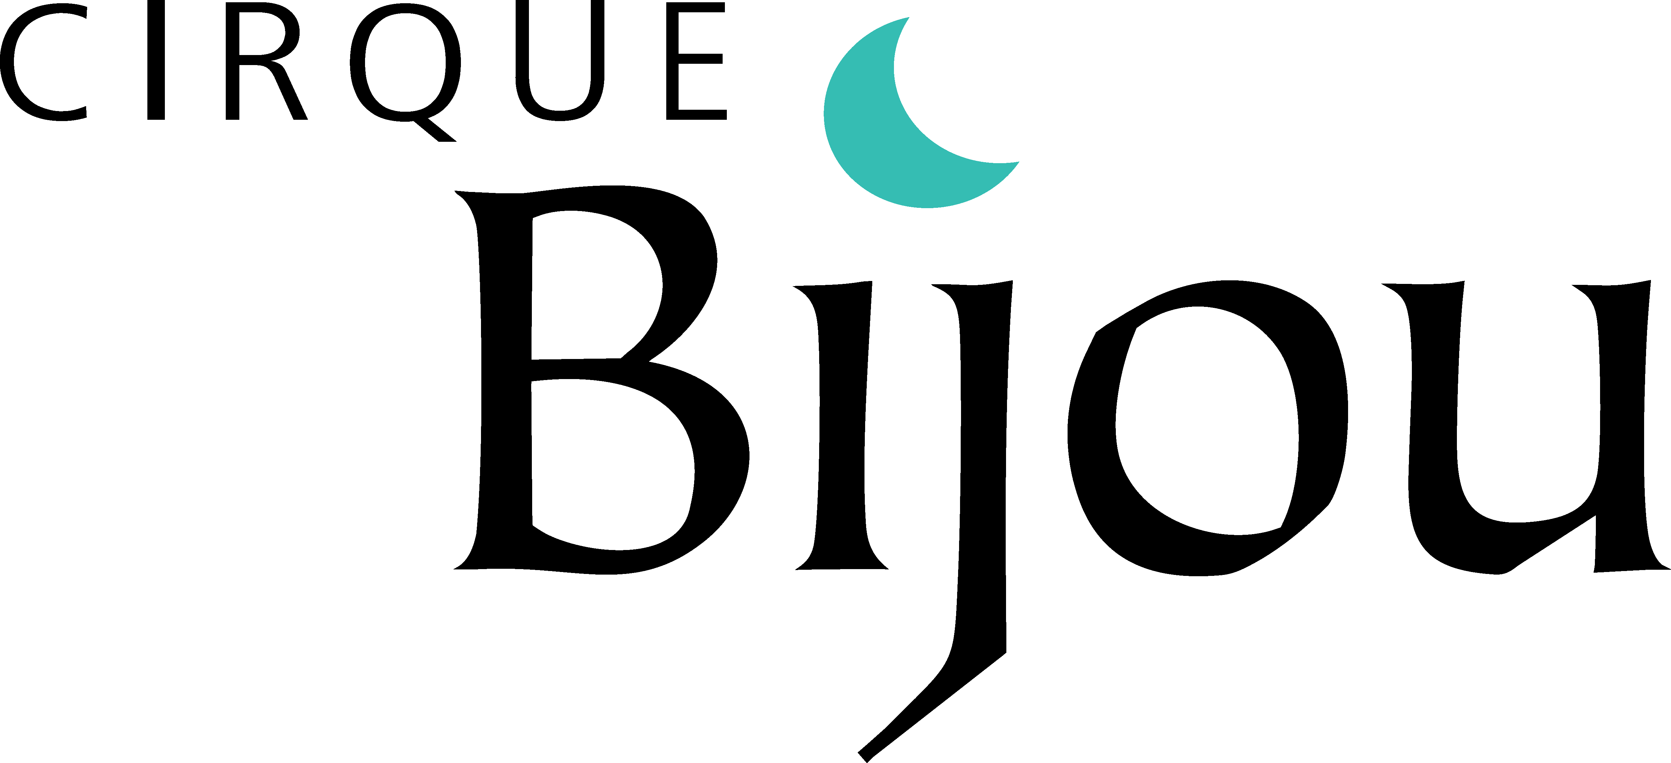

[**Cirque Bijou**](http://cirquebijou.co.uk) works across the commercial and public sectors, making circus shows with a vast range of communities nationally and internationally. It brings together emerging, community and world-class artists in collaborative, accessible shows. The company’s work is shown in many different environments, including parks, festivals, city centres, stadiums, living rooms and kitchens, on beaches and in the street.  The Company, established in 1999, is a sustainable not-for-profit organisation and creative powerhouse with a team of producers and global network of collaborators, supported by mix of Arts Council project funding, local authority commissions and wide-ranging commercial projects.